Quick Start Manual
for mkusb version 8
by sudodus alias nio-wiklund at launchpad

a. Preparation
You need two drives or mass storage devices (pendrive, flash card, HDD, SSD). The minimum sizes are 1 GB and 4 GB, but obviously the final operating system will soon need more space for your personal files as well as for additional system files (program packages),

- a drive for the installer (minimum 1 GB for a CD size iso file, typically 4 GB USB pendrive), and

- a drive for the target, the final installed operating system (typically an internal drive, but it could also be connected via USB or eSATA). Minimum 4 GB for Lubuntu but 8 GB or more is better, and will work with all desktop flavours of Ubuntu and many other linux operating systems.

b. Backup all personal data before trying this method because the installer drive and maybe also the target drive will be completely overwritten

c. Install and or download the files

Install (or download) the shell-script mkusb and download a hybrid iso file or compressed image file with the operating system.

mkusb can be installed from PPA with the following commands

sudo add-apt-repository ppa:mkusb/ppa # and press Enter
sudo apt-get update
sudo apt-get install mkusb

These commands install the standard mkusb with a graphical user interface plus the text-only version, alias mkusb-nox. 'No X' means only text mode, a version to be used with text screens and in terminal windows. It is useful for servers and other systems without a GUI, and it needs no extra packages.

Current Ubuntu iso files can be used (including the mini.iso file of Ubuntu 14.04 LTS but not the mini.iso of 12.04 LTS). Image files and compressed image files can also be used.

file.iso file.img file.img.gz or file.img.xz

Download also the corresponding checksum files, usually md5sum. See the following links

https://help.ubuntu.com/community/mkusb
http://phillw.net/isos/linux-tools/mkusb/

d. Check download and clone image in Linux

1. Change directory to where you have the downloaded files.

2. Check that the download was successful with md5sum

Example:

md5sum xubuntu-14.04-desktop-i386.iso mkusb

3. Use mkusb to install/clone/flash the operating system

mkusb helps you find the correct target drive and avoid the risk with dd.

If installed, mkusb is in the system PATH and can be started with sudo mkusb

If downloaded, make mkusb executable sudo chmod ugo+x mkusb
Run mkusb -h (locally with prefix ./) to find out how to use it

$ ./mkusb -h
Usage: # New: menus to select source file and target device #
---- Make a USB install device from ISO or image file --------
sudo -H ./mkusb
sudo -H ./mkusb file.iso
sudo -H ./mkusb "quote file name (1) with special characters.iso"
sudo -H ./mkusb file.img
sudo -H ./mkusb file.img.gz
sudo -H ./mkusb file.img.xz
---- Install from 'file.img.xz', show all mass storage devices
sudo -H ./mkusb file.img.xz all
---- Wipe the USB device (may take long time) ----------------
sudo -H ./mkusb wipe-whole-device
---- Wipe the first megabyte (MibiByte), show only USB devices
sudo -H ./mkusb wipe-1
---- Wipe the first megabyte, show all mass storage devices --
sudo -H ./mkusb wipe-1 all
---- Help and Version ----------------------------------------
./mkusb -h
./mkusb -v

The current version of mkusb uses text based menus and graphical windows to help you select the correct source file and target device. mkusb can monitor the data transfer with pv, and suggests that you install it, if not yet installed. pv shows Mibibytes and dd shows Megabytes.

mkusb needs dialog and wants zenity, and suggests that you install them. If you cannot install dialog, for example because you have no internet connection, you should use mkusb-nox or an earlier version, 7.5 or earlier. The older versions are available at this link

http://phillw.net/isos/linux-tools/mkusb/

mkusb is described with more details at the wiki page

https://help.ubuntu.com/community/mkusb

If you have installed mkusb from the PPA, it will be updated together with other installed programs, and there is a manual page for mkusb and mkusb-nox

man mkusb

The first example describes cloning an iso file to a USB pendrive.

sudo ./mkusb

opens the menus to select the source file.

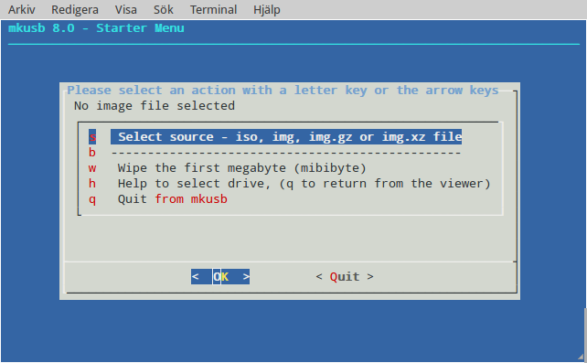

mkusb skips directly to the menus to select target device with the source file as parameter.

sudo ./mkusb xubuntu-14.04-desktop-i386.iso

You clone the same version and flavour of Ubuntu several times during iso testing. Then it will be very convenient after the first time.

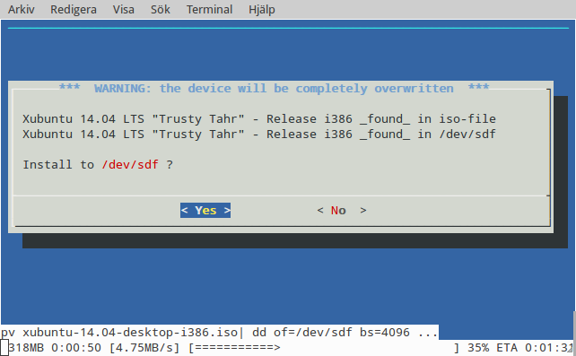
The target in this case is a reliable but slow Sandisk Cruzer Blade 4 GB USB 2 pendrive. Fast USB 3 pendrives can write 5 times faster in USB 2 ports and even faster in USB 3 ports. See this link, How to help USB drives in the Ubuntu Forums, post #6

http://ubuntuforums.org/showthread.php?t=2196858
The next example shows how to search for source files

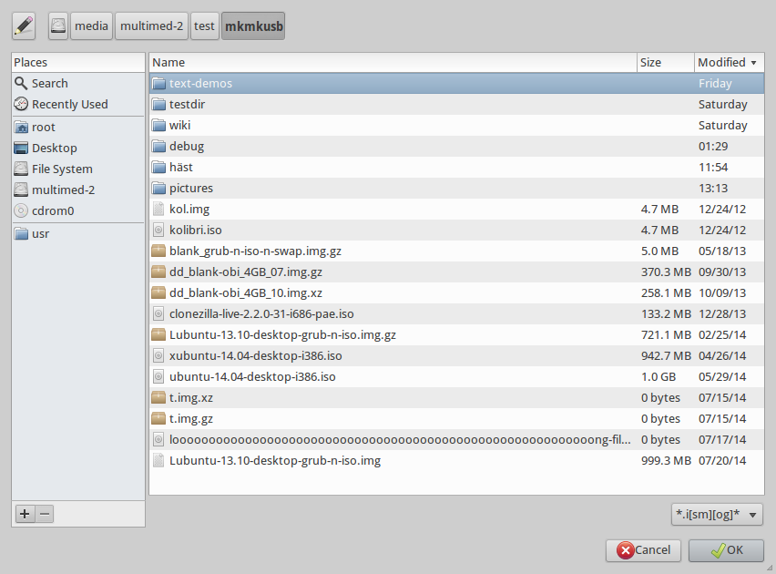

This example shows selecting 'Install' and selecting the target device
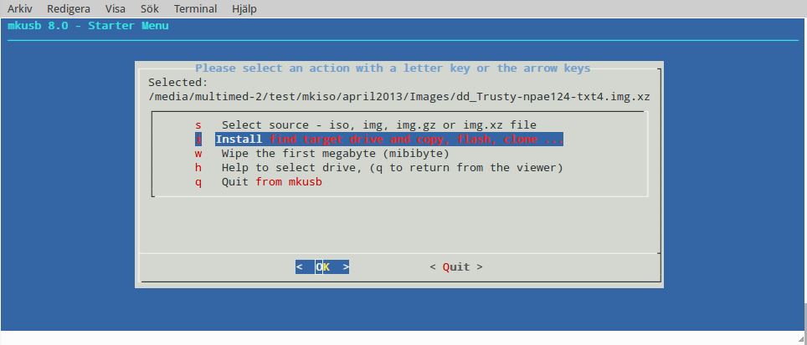
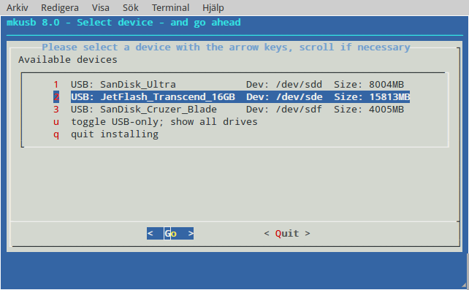
Look out for the FINAL WARNING in the next screen!

Double check that it is the correct target device, before you decide to install!

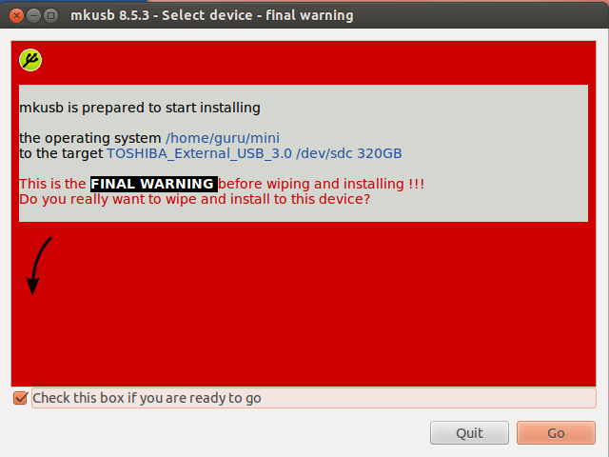

e. Wipe the CD file system

If you want to re-use a USB device that has been used with an iso file system, iso9660, you should wipe it with dd (overwrite with zeros). Otherwise grub-install doesn't want to write into the mbr area, because it recognizes the CD file system. You need not wipe it before cloning. Use mkusb also for this task and wipe the first megabyte of the drive, 'wipe-1'.

sudo ./mkusb wipe-1

or

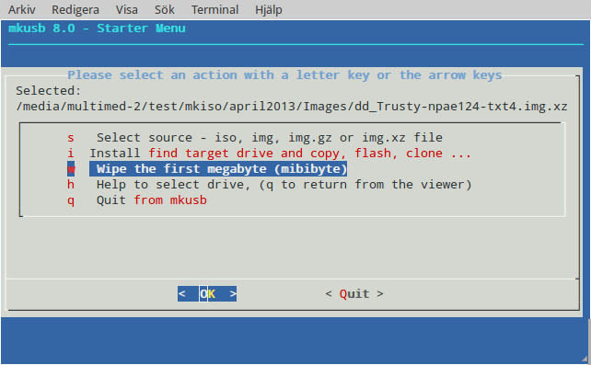
and you will arrive at menus to select the target device and the FINAL WARNING

f. References

See the tutorial in the Ubuntu Forums for more details

http://ubuntuforums.org/showthread.php?t=1958073

alongside the previously mentioned links
https://help.ubuntu.com/community/mkusb

http://phillw.net/isos/linux-tools/mkusb/

And read this wiki page with methods and tools to create USB boot devices/drives/sticks

https://help.ubuntu.com/community/Installation/FromUSBStick

